Historic Rosemont Manor
A History

Written and Compiled by Suzanne Pearson

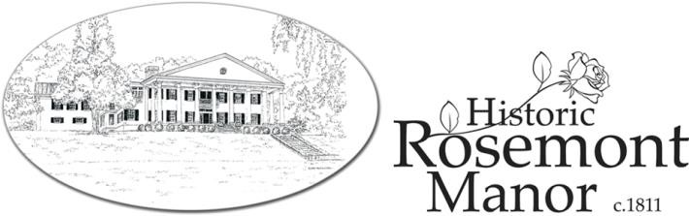

Introduction
Much has been said about Rosemont Manor and its history of Presidential helicopter landings and
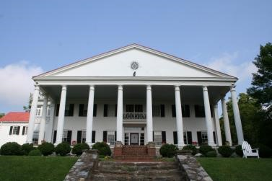
high-powered political luncheons—and rightly so. The threshold of the manor has been crossed by several U.S. Commanders in Chief as well as other dignitaries and celebrities over the years, but the history of Rosemont runs much deeper. The stately home at Rosemont brings alive the expression, “if these walls could speak”, as so much has taken place here _{A view of Historic} Rosemont Manor
from the lower East Lawn in the lives of those who have called Rosemont “home”. Further, the events that have occurred here through the generations have served as a backdrop for the history of the Shenandoah Valley, the Commonwealth of Virginia, and of the formative years of the United States.
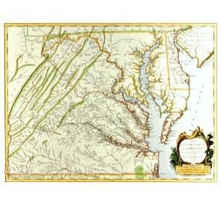
The genesis of Rosemont Manor begins in the 18th century with a parcel of land in the Northern Shenandoah Valley known as the Fairfax Grant. This particular portion of land was offered by the English crown to whomever such brave “pioneers” as were willing to cross the Blue Ridge
Mountains into the less charted valley region of Virginia. (One such pioneer to leave his family’s homestead in the Tidewater area of Virginia
A map of the region in the late 1700’s to settle in the valley during this time was Thomas Taylor Byrd, but his
Rosemont story doesn’t really begin until later.)

The Norris Era (1811-1857)
One particular plot of land within the Fairfax Grant was owned by a gentleman by the name of Ralph
Wormeley. Mr. Wormeley and his family, which included a daughter, Jane Bowles Wormeley, did not live on this land, but rather resided several miles away in a home called “Cool Spring” on the Shenandoah River.
Sometime around the turn of the 19th century, Jane was being courted by a young man named George Horton Norris, and her father must have thought well of the match, as he either gave or sold his land holding to George Norris on which to build a home. Though the exact date of George and Jane’s marriage is unclear, it is believed that the Norris family may have been living on the Rosemont property in a smaller structure as early as 1804. The first part of the current Rosemont manor house was constructed in 1811 as a belated
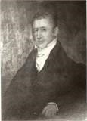
wedding present for Jane from her husband. The happy couple named their new home “Rose Mont”.
George and Jane Norris must have lived a successful life at Rosemont, as
children are recorded to have been born at Rosemont: one daughter and eleven sons! In
1836, George Norris was appointed the first High Sheriff of Clarke County.
George Norris
George and Jane’s only daughter, Arianna Charlotte Norris, born and raised at
Rosemont, may have been the very first “First Lady” (bride) at Rosemont. She is recorded to have married Howard F. Thornton on December 18, 1833, presumably on the grounds of her home. Rosemont continued to be the homestead of this next generation, which included Howard and Arianna’s daughter, Fannie Hawes Thornton, born at Rosemont on the fourth of July, 1837.

The Tyson Era (1857-1902)
Fannie Thornton must have been quite a “catch”, as she attracted the
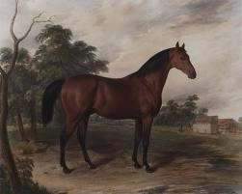
eye of a wealthy young man by the name of Isaac Tyson, III. The Tysons were a wealthy family from Baltimore, Maryland who had made their fortune in chrome and copper mining. They also bred champion racehorses – a pursuit which would later play a part in Rosemont’s history.
One of a series of paintings by Edward
Troye – Race Horses of America
During the time that Isaac was likely courting the young Miss ₍₁₈₃₂-1872)

Fannie, the following diary entry was recorded by her cousin on Christmas Eve, 1853:
“I have been helping my good aunt [Arianna Thornton] to meet the New Year….I have been covering
the union chairs with some scarlet stuff. They look well at night, the parlor dressed in green cedar, lit up with a dozen wax candles, bright hickory fire to welcome Mr. Tyson. The three Mrs. Harrises and Mr. Bennett Norris and others came to drink egg nog.”
Isaac Tyson III and Fannie Thornton were married at Rosemont on October 4, 1854. At that time, the
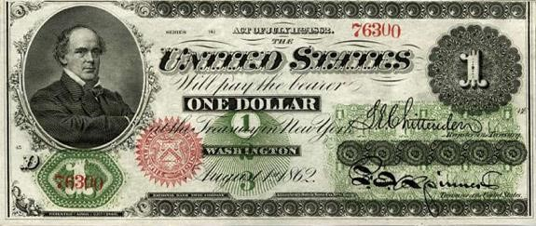
property was still owned by Fannie’s father, a fact which bothered Isaac. He wrote several letters to his father, Isaac Tyson, Jr., between 1854 and 1857, asking for the $15,000 that would be necessary to purchase Rosemont from his father-in-law. It is assumed that Isaac, Jr. eventually relented, or perhaps Isaac III found another funding source, because a deed of sale records Isaac III purchasing the property for a total of $18,922 on December 11, 1857. Sadly for the younger Isaac Tyson, he apparently made some very unwise financial decisions, and by 1858, he had incurred so much debt, that he was forced to sell Rosemont to his father for $1, in exchange for his father’s help in rectifying his financial
A dollar bill from the time of the disasters. When Isaac Tyson Jr. died in 1861, he disinherited his ^{Tyson Era}
namesake completely, saying that Isaac III was “unable to take care of himself” and would therefore not share in any part of his father’s estate. Rosemont was left in trust for Isaac Jr.’s other two sons, Jesse and James.

Improvements to Rosemont
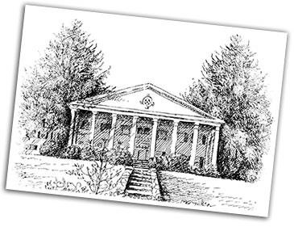
Between 1840 and 1860, the Grand Portico was added to the Eastern façade of the manor. The portico, with its Greek-Revival style Doric columns, served as a festive and formal entrance for many gentlemen and ladies who came by carriage to call on the Thorntons and Tysons during those antebellum days.
A sketch depicting the Manor after the addition of the Grand Portico
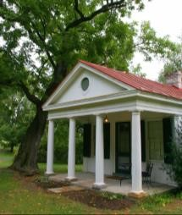
It is likely that Rosemont’s “honeymoon suite” cottage, now named “The Byrd’s Nest”, was probably built during this era as well. This charming structure, complete with a wood-burning fireplace, was seemingly constructed as a miniature version of the manor with its Doric columns, and mid-19th century architecture. What the Tysons used this
structure for is unknown, but it may have been a business office or the quarters of the The Byrd’s Nest
caretaker.

The Civil War Years
Thus on the verge of the Civil War, Rosemont’s future was uncertain. It is unclear who from the Tyson
family was living in the manor at that time, but the estate, then called “Rosemont Farm” was a thriving stock farm for the Tysons’ many thoroughbreds. A great stable stood on the grounds at that time (it was later destroyed by fire) in addition to the Carriage House which, beautifully restored, now hosts wedding receptions and other events at Rosemont.
By 1862, the “War Between the States” was in full force throughout the Shenandoah Valley. It appears
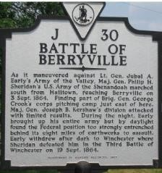
that by this time, the Tyson family was not living at Rosemont, but the estate was under the care of the horse handlers and a caretaker named Owen Reisler, who was paid in $35 increments to check in on things periodically at Rosemont. A letter from an unnamed source to the Tyson family dated January 30, 1862 indicates that Confederate troops were making themselves right at home on the Rosemont Farm grounds. The letter states that the soldiers were helping themselves to mules, corn, bacon, horses, and wagons, and had even threatened to seize the property altogether.But the biggest excitement was yet to come. On September 3, 1864, Confederate troops under the command of General Jubal Early were passing through Berryville on Lee’s orders to return to Petersburg.
During this journey, they were met by Union General Philip Sheridan’s forces
on “Grindstone Hill” – a small knoll near Rosemont. The battle lines were Battle marker detailing the Battle of
Berryville
drawn, with Confederate troops occupying the woods at the southern end of the Rosemont property. The Confederates drove Sheridan’s troops from their strong position in Berryville. This altercation, commonly referred to as the “Battle of Berryville”, had Rosemont Manor and the surrounding grounds as its focal point, which is well-evidenced by the recent findings of many Civil War relics on the property, including uniform buttons, artillery shells, and hundreds of lead bullets.

Post Civil War Years and Changes in Ownership
After the Civil War, Rosemont Farm continued in the hands of the Tyson family as a working stock farm
for horses and possibly other livestock. In 1867, the entirety of the estate (house, farm, and stock) was valued
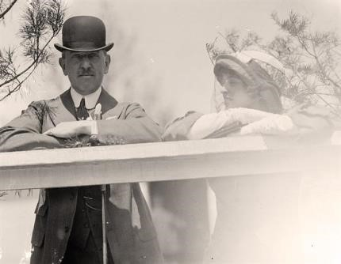
at $28,503.29. The Tysons maintained this business use of Rosemont until 1902.
Jesse Tyson sold Rosemont to Charles E. and Cornelia Clapp in 1902
for $23,235.75. The Clapps maintained the property for 7 years before selling it to Arthur L. Warthen in August of 1909. Warthen owned
J. Low and Elizabeth Harriman Rosemont for only one year, and then sold the estate to New York attorney J. Low Harriman (cousin to famed New York Governor and U.S. Ambassador, W. Averill Harriman) and his wife Elizabeth on August 31st, 1910.

The Harriman Era (1910-1917)
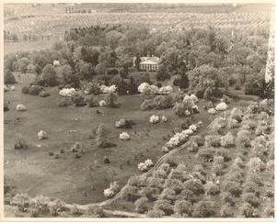
J. Low and Elizabeth Harriman must have loved Rosemont and wanted to see it flourish once again as a thriving personal residence. They set at work immediately to update the plumbing system in the manor. They also added several new features to the manor house, including the grand staircase off of
Aerial view of the manor and grounds

the foyer. They added the sun porch, and just above it, the “sleeping porch” which now comprises part of the Nixon Suite. The Harrimans added an Italian garden to the grounds, just south of the manor. Their biggest project, however, was the addition of the wing, which added another eight bedrooms to the house and significantly increased its square footage.
In 1917, the Harrimans sold Rosemont to William Morgan Smith and his wife, Anne Staunton Smith.
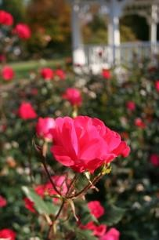
Recently a great-granddaughter of the Smiths came to tea at Rosemont and related stories of visiting here as a child. She said that the ladies of the house were served breakfast in bed and rarely rose before 10 a.m. She said that her grandfather’s rose garden was well-known in Berryville and that as a child, she believed that the name of the estate was due to those
prized roses. We now know this not to be the case, but it is notable that Dr. Smith chose Present-day
rosebushes at the
to grow the fragrant blooms which shared the name of his historic home. gazebo on the
grounds of the manor
At some point in the 1920’s, the larger cottages were also built on the grounds at Rosemont. The
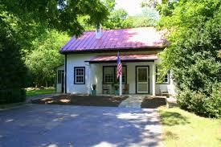
three larger structures, now called “The General Philip Sheridan Cottage”, “The General Jubal Early Cottage” (named after the principle commanders for the Union and Confederate forces who fought in the Battle of Berryville), and “The John Wayne Lodge” were used as tenant houses. The Byrd’s Nest, built most likely during the Tyson
Era, was at that time used by Mr. Harriman as a private law office. During the
The John Wayne Lodge recent renovations of this structure, law books dating back to 18th century
England as well as copies of the U.S. Congressional Records from the 1830s were discovered in the attic.
Members of the Byrd family who later lived in Rosemont said they never even knew the books were there.

The Byrd Era (1929-1997)

Family History
This brings us to probably the best-known chapter in Rosemont’s history – the entrance of Harry Flood Byrd, who purchased the estate in 1929. But the Byrd Family’s history was intertwined with Rosemont’s history long before that deed of sale. As mentioned before, Harry Byrd’s ancestor, Thomas Taylor Byrd had left his family home of Westover, located near Wiliamsburg, VA in the 1780’s and settled on a small parcel of land very near to the current property lines of Rosemont.
This thread of the Byrd family lineage had remained in the Winchester/Berryville area ever since.
Harry F. Byrd, Sr. was the oldest son of Richard Evelyn Byrd and Eleanor Bolling Flood Byrd. Harry’s brother, Richard E. Byrd, Jr. would later become the great Admiral Byrd, who is said to have led the first by-air expeditions of both the North and South Poles. Richard and Harry also had a brother named Thomas who would become an esteemed businessman in the Shenandoah Valley. These three highly successful brothers were truly not your average “Tom, Dick, and Harry”.
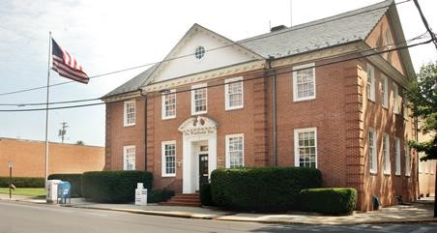
Harry Byrd was an entrepreneur and leader right from the start.
When Harry was a child, his father (who at one time held office as the
Speaker of the Va. House of Delegates) owned the Winchester Evening
Star newspaper, and business was not going well. When Harry was 15,
The building for the present-day
the paper had nearly gone bankrupt and his father was prepared to sell. Winchester Star, formerly the
Winchester Evening Star
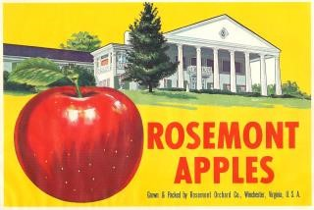
Harry believed he could turn things around, and his father took a chance on him. Harry dropped out of school to run the paper, and within a year, the business was thriving again. Harry also used his shrewd business sense to invest in what he saw as an up and coming industry – apple orchards. Harry began leasing out apple_{Vintage Rosemont Apples label} bearing land as early as 1911, and in 1913, he purchased “Rosemont Orchards” which was a purchase separate from, but adjacent to the estate. In 1917, Harry built a log cabin on the grounds of the orchard, so he was literally “next-door neighbor” to the manor he would later own. Harry and his wife, Anne Douglass Beverly, affectionately known as “Sittie”, also had a house in Winchester, but they spent their summers at the Rosemont Orchards cabin. One can’t help but wonder if they looked across the fields to the beautiful manor on the hill and wondered if they might live there some day.

The Purchase of Rosemont
Harry Byrd’s two businesses – the Winchester Evening Star and the Byrd Orchards – both flourished
under Harry’s careful direction. His political career began to take flight as well. In 1926, Harry was elected governor of Virginia, where he served faithfully until 1930. It was during this era that Harry Byrd realized what may have been a dream for quite some time – he purchased Rosemont from the widowed Mrs. Smith in the summer of 1929. Harry’s son, Dick Byrd, would later say, “If Father had waited until the next year, he would have paid a great deal less!” [due to the stock market crash of Oct 1929]
Harry F. Byrd Senior and his boys: (left to right) B. Beverly, Harry F. Sr., Harry F. Jr., Richard E.
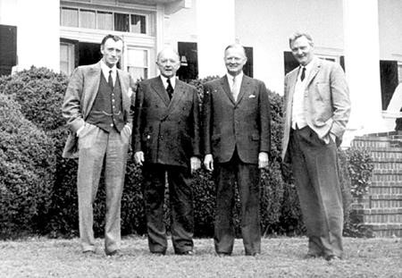
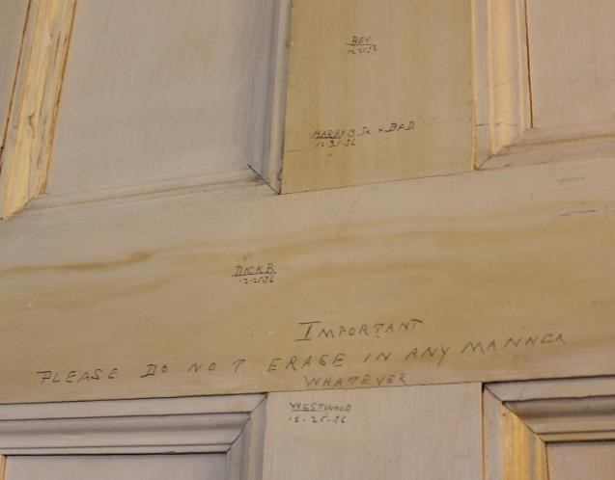
Thus as 1929 came to a close, Harry moved into Rosemont with his wife and their children. These included three sons: Harry Jr., Richard (Dick – named after his famous exploring uncle), and Beverly; and a daughter, Westwood. One memento of the Byrd family’s time at Rosemont is immortalized by the penciled
Back of the door in the Byrd Study etchings on the back of a door in what is now the Byrd Study: a height chart showing the heights of the four Byrd children, along with the words, “Important: Please do not erase in any manner whatever”. The heights are dated Christmas Day, 1936.
The Byrds completed extensive landscaping of the grounds at Rosemont, and added changes that must have been heavily-lobbied by the Byrd children – new clay tennis courts and an update to the swimming pool that the Harrimans had installed. The Byrds also added the wood paneling in the formal dining room, which is now the Nimitz Lounge.

A Gracious Host
Right from the beginning, Harry instituted an “open door” policy for visitors at Rosemont. He felt that
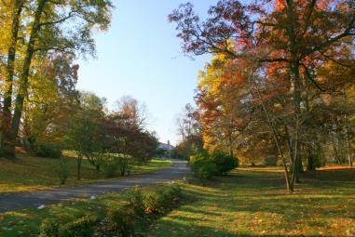
it was because of his standing as governor of Virginia that he was able to live at Rosemont, and therefore the constituents of Virginia had the right to visit him there. He posted a sign at the entrance gates to Rosemont that said “Visitors Welcome” and it remained there until his death in 1966.
Although Harry may have been a laid-back host, his open invitation
Present-day view of to Rosemont did cause some problems from time to time. It was well-known ^{Rosemont Manor Lane} that Sittie was not a big fan of the frequent visitors, and she was rarely seen by those who stopped by.
The story is also told by Harry’s grandson, Harry Byrd, III of a time that he and his grandfather slipped
down to the pool to go skinny-dipping in the early evening. This was the unfortunate state they were in when a small group of constituents walked up on them. Harry III says that his grandfather spoke at length to his guests, all the while leaning up against the side of the pool and taking advantage of the fading light to hide
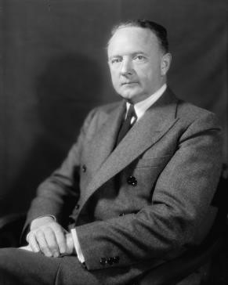
what was beneath the surface of the water! The younger Harry says as the sun set, the water grew colder and colder, but they didn’t dare think of getting out. The entire conversation took over an hour, and in the end, the visitors left none the wiser. However, Harry says his grandfather was a little more careful about his skinny-dipping after that!
Senator Harry Flood Byrd,
Even “after hours” visitors were tolerated at Rosemont – to a point. Bob Senior
Ferrebee, a Berryville “local”, recalls sneaking on to the grounds at Rosemont as a teenager with his friends to swim in the pool in the middle of the night. Bob said the Senator came down in his bathrobe, told them to quiet down a bit, and then went right back to bed.
The other caveat of the open door policy was that although Harry was always dressed to the nines when at work in Richmond (and later Washington), he was known to be quite casual when at home at
Rosemont. Many stories are told of Harry greeting visitors in his pajamas – regardless of the time of day. Grandson Harry III was once again involved in an embarrassing moment with his grandfather when he brought a girlfriend to Rosemont and was greeted by the elder Harry wearing pajama pants being held up by a rope.

Harry, III says, “I never heard from that girl again.”
Politics
In March of 1933, Harry Byrd Sr. was appointed by the
Democratic Party to fill a vacant Virginia seat in the U.S. Senate. It was a
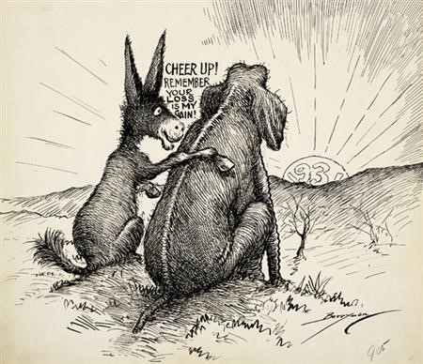
Political carton from the 1930’s: Cheer up! Remember: your loss is my gain!

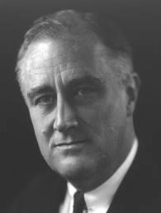
post that Byrd would be re-elected to multiple times, serving nearly 33 years on the Senate floor. It was during these 33 years that Byrd’s power and influence began to make a real impact on U.S. politics. Harry and his colleagues became known as “The Byrd Machine” - -a group of men who all but decided who would hold every important office in Virginia. It is interesting to note that although Byrd was a life-long democrat, his political leanings were decidedly conservative throughout his career. Perhaps it was this strange combination of bipartisanship that made Byrd so popular that he ran several races unopposed. Regardless of party affiliation, no Washington insider would have questioned the power and influence of Harry Byrd. And it was at Rosemont Manor that many important political discussions took place.
One of the earliest of such encounters occurred just before the Democratic
National Convention in 1932. Harry Byrd was a front runner for the democratic
President
Presidential nomination, as was another powerful gentleman by the name of Franklin Delano Roosevelt
Franklin Delano Roosevelt. Just before the convention, FDR made a surprise visit to Rosemont to chat with Harry Byrd. Such a surprise, in fact, that when FDR came knocking at the door late at night, Harry’s brother-inlaw mistook him “for a drunk being put to bed to sleep it off.” In fact, Roosevelt was there to offer Harry a proposition. He said that if Byrd would offer his support to help FDR win the Presidential nomination, in return he would choose Byrd as his Vice-Presidential running mate. Harry was at odds with FDR’s liberal stance on economic issues, and politely turned down the offer. During the convention, the party went through three
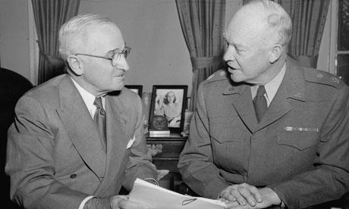
deadlocked votes before Byrd and others finally relented in the name of progress and gave their reluctant support to Roosevelt.
Senator Byrd would later go on to develop close friendships with both President Dwight Eisenhower and
_{President Harr}y Truman (left) and eventual President Harry Truman. Although he sometimes adamantly President Dwight Eisenhower (right)
disagreed with their politics, Senator Byrd remained a gracious host and it is likely that both presidents spent ample time at Rosemont over the years.

Sunday Luncheons
Rosemont is known to have been the site of high-level government discussions on everything from
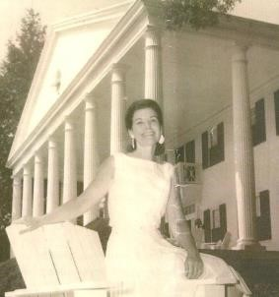
presidential nominations to desegregation, but it was also a place where dignitaries and politicians came to escape the world of politics. The Sunday luncheons, an ongoing tradition that became legendary at Rosemont during Senator Byrd’s years, were known for being mostly, if not entirely, social events rather than political ones. Helen Byrd, daughter-in-law of the Senator, was quoted as saying, “I think
Helen Byrd the Senator’s colleagues felt very at home here because all conversation was always off the record. The guests were never badgered by reporters, although many famous members of the press were invited as social guests.”
Whenever a luncheon was to be held (periodically throughout the year), lists of potential guests would
be sent to Rosemont from the Senator’s D.C. office on the Monday prior, but by Thursday, the list would have grown much larger. The house staff at Rosemont would scramble to accommodate the guest list of up to 150, some of whom would sometimes end up sitting on the stairs. Cocktails were served on the portico before a meal that usually included ham, fried chicken, biscuits and gravy, crabmeat, and strawberry shortcake.

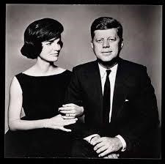
Presidential Visits
During the start of one such luncheon, the guests who had already gathered on
the Portico were interrupted in their conversation by the sound of approaching
helicopter blades. The Senator raced off the Portico, down the stone steps, and onto the
President and First Lady Kennedy
East Lawn to meet the occupants of the chopper. He returned moments later, all smiles and flanked on either side by his VIP guests – President and Mrs. Kennedy.
Another famous visit took place just a few years later on May 18,
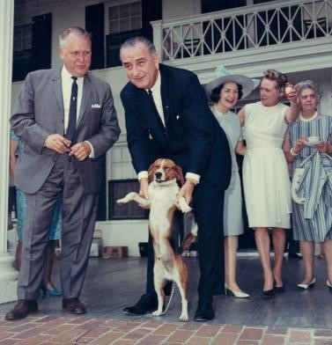
1965. Coming to lunch that day were President Lyndon B. Johnson, his wife
Ladybird, and their beagle – a livewire named “Him”. The President and the Senator decided that “Him” should meet the Byrd family pet, a cocker spaniel named “Pam”. The encounter took place in the Senator’s study
(now a guest suite called the Byrd Study) and it did not go quite as
President Johnson and ”Him” during the planned. The two canines immediately erupted into a literal dogfight and memorable visit the President was caught in the middle. Secret service agents entered the fray to protect their charge, and the Senator also aided in ending the skirmish. Local papers quipped that the dogs’ reaction to one another was an allegory for the political differences between their owners. All politics aside, the Byrds and the Johnsons laughed over the incident and seemed to enjoy a lovely luncheon and afternoon together.
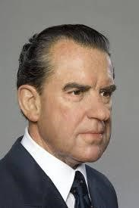
The last reported Presidential visit to Rosemont is said to have taken place after
the house had passed to the Senator’s son, Dick Byrd. The story is told that visitors stopped by the manor to visit with the Byrd family and walked in on an unexpected sight during the height of the Watergate scandal – President Richard Nixon, seated at the dining room table. It would appear that Rosemont was a welcome reprieve from the press and
President Richard Nixon others during the firestorm of the investigation.

Other Famous Visitors
Presidents were not the only well-known guests at Rosemont during the Byrd era. Military leaders
such as General George Marshall (who also served as U.S. Secretary of State), Admiral Chester Nimitz, and of course Admiral Richard E. Byrd were all guests at one time or another.

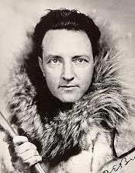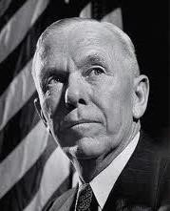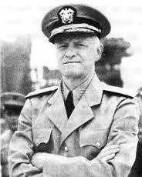
General George Marshall Admiral Chester Nimitz Admiral Richard E. Byrd
An anecdote is told among the Byrd family about a visit that Admiral Byrd made to his brother Harry at Rosemont. Apparently, the Senator was known for keeping the temperature quite cold inside the house. (His secretaries were known to work all day wearing their coats!) On this particular overnight visit, the Admiral came out of his room in the morning wearing his overcoat on top of his pajamas and called down to his brother, “My God, Harry, can’t you put that thermostat up a bit?” This is quite an amusing statement coming from a man who spent most of his time at the South Pole!
Other esteemed visitors to the Byrds included Albert Einstein, Winston Churchill, John Wayne, and
Charles Lindbergh (pictured below).

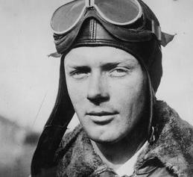
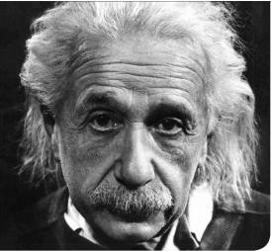
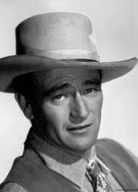
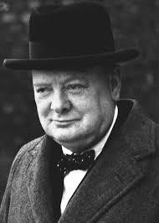
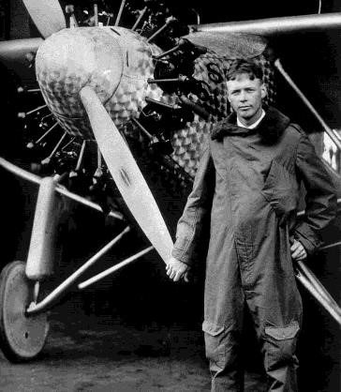
The Senator and the famous aviator were known to do quite a bit of
quail hunting together on the grounds at Rosemont, but on one particular visit, it was Harry’s wife “Sittie” who got most of Lindbergh’s attention. The Byrds went to greet Charles when he flew into Winchester. Charles offered to take Mrs. Byrd for a ride in his personal airplane. Family members remark that, being a rather unadventurous sort, Sittie must have wanted to decline but out of a sense of gracious obligation, she agreed. Lindbergh took her up in his _{Aviator Charles Lindbergh} plane, and proceeded to do a fly-over at Rosemont where guests were gathered on the Portico. The story goes that Lindbergh “buzzed” right over the top of the Portico close enough for Mrs. Byrd to wave to her guests, but she was too terrified to do so.
Beyond the “A-list” guests at Rosemont, there were other events that drew a crowd. Every year from 1924 to 1964, Byrd hosted the “Annual Apple Picnic” – at his orchards adjacent to the manor. Thousands of apple growers came from all over for this event which served as a convention, a festival, and a political rally, all in one.

The End of an Era
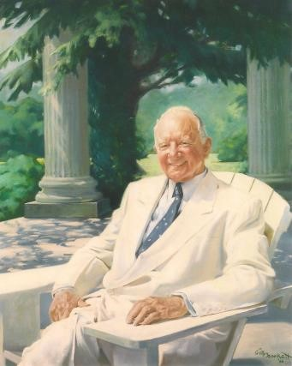
Senator Byrd and Sittie celebrated their Golden Wedding Anniversary Gala at Rosemont on October 7, 1963. It would be the last social event for Sittie who was in failing health after suffering both a heart attack and a stroke. Though their daughter Westwood had died years earlier from complications of a hunting accident, the couple’s three sons had all grown into upstanding young men who served their country during WWII and went on to live successful lives. Harry Jr. joined his father in both in politics and in the operation of the Portrait of Harry Flood Byrd Senior
Winchester Star. Beverly Byrd lived on a plot of land adjacent to Rosemont
where he kept a wild animal preserve complete with buffalo, llamas, camels, yaks, and a variety of goats and fowl. Richard continued his father’s legacy by maintaining the family apple business.
In the months following the anniversary gala, Mrs. Byrd’s health
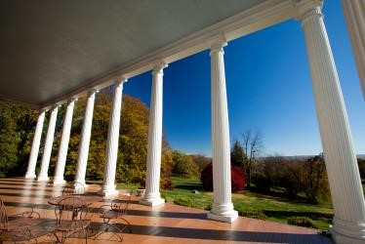
declined dramatically and she passed away at Rosemont in August of 1964. About a year later, the Senator was diagnosed with a brain tumor, and was forced to resign from the U.S. Senate in November 1965 for health reasons. He
retired to his beloved Rosemont, where he spent his last months here with his A view from the Grand Portico faithful canine companion, Pam, by his side. It was said that Rosemont was one of the Senator’s favorite places in the world, and when he sat on the Portico, “his hearty, booming laughter could be heard across the valley”. Harry Flood Byrd, Sr. passed away at Rosemont on October 20, 1966. Staying in the Family
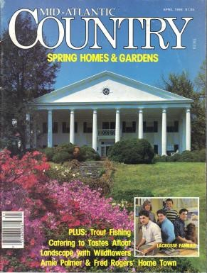
After the Senator’s death, Rosemont Manor was inherited by his son, Richard (Dick) and Dick’s wife, Helen. The couple moved to Rosemont with their three children, Bill, Lucy, and Ricky. At that time, Rosemont was no longer open to visitors, but Dick and Helen were gracious hosts who held occasional lunches and “old-fashioned balls” at Rosemont. The manor was twice featured in Town and
Country Magazine – December 1975 and again in October 1985, in articles which
Mid-Atlantic Country magazine featuring  Rosemont on the cover of the April 1986 edition | featured the historical significance of Rosemont.
In April of 1968, Rosemont was opened up for “Garden Week Tours”, at
which time the home and grounds were toured by close to 6,000 people. Also in 1968, Helen Byrd hosted a benefit Fashion Show and Tea for the Clarke County Visiting Nurses Association. The categories of clothing for the fashion show included: Leisure Hours, Virginia Countryside, Cocktails and Dining, and Dancing on the Terrace. Also serving as patronesses for this event were Helen’s two sisters-in-law, Mrs. Harry Byrd Jr., and Mrs. Beverly Byrd.
Helen Byrd was also a patroness of the arts, and had great involvement with community theater in Berryville. The rooms in the wing at Rosemont were used to house actors who had come to the area to perform.

The Jones Era (1997-2009)
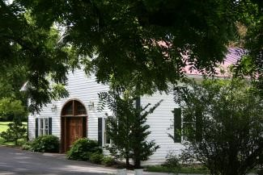
Dick and Helen Byrd maintained Rosemont as their residence until 1997.
At that time, Rosemont was purchased by Randolph and Susan Jones of Northern
Virginia. The couple began extensive renovations of the house, including turning the two main floor guest bedrooms into a game room which now comprises the The Carriage House
Roosevelt Suite, and two bedrooms on the second floor into one large suite that now is the Eisenhower Suite. They also rewired the manor and adorned the house with many creative painting techniques. The Joneses held several charitable functions at Rosemont, including benefits for the Clarke County Educational Foundation which was held in the Carriage House. When it wasn’t being used for such events, the Carriage House was home to Randy’s collection of antique and foreign cars.

The Genda Era (2009-Present)
During the height of the housing boom in 2005, Rosemont
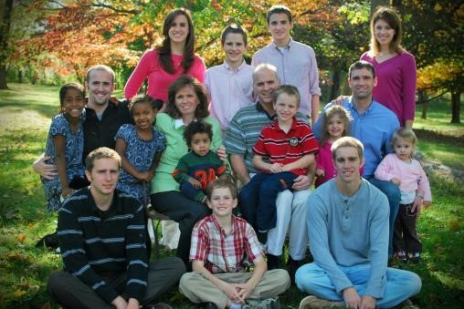
was in danger of being lost to development. In part to save this historic site from future development, Clarke County residents
William ”Biff” and Barbara Genda purchased the property from the Joneses with the intent of preserving the land and turning Rosemont into a Bed and Breakfast and special events venue. After the sale
The Genda Family

was completed on September 30, 2009, the restoration begun by the Joneses continued.

Improvements
The main manor house was the first structure to see major changes. The 90 year old plumbing from
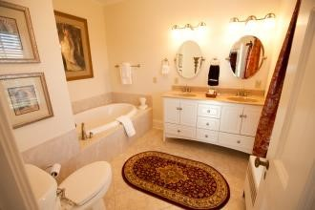
the Harriman Era was re-plumbed and six new bathrooms were added, giving each guest bedroom and suite a private bath. A new water main was brought in from the town, along with the installation of a fire suppression sprinkler system to meet fire building code requirements. A high-efficiency, twenty-seven zone heating and air conditioning system was installed bringing oil consumption of the
An example of the updated facilities still functioning steam and hot water boiler system from a yearly high of 3000
gallons to a mere 100 gallons annually.
On the rest of the Rosemont Estate grounds, the entrance and exit driveways were brought up to VDOT standards, handicap accessible bathrooms and a kitchen were added to the Carriage House, and a wedding studio and bridal office were created. The three guest cottages along with the “Byrd’s Nest” were completely renovated and decorated to serve as additional overnight accommodations for wedding guests. All of these improvements further enhance Rosemont’s ability to accommodate the needs of our guests and to offer the best in comfort and elegance while continuing the rich history of making Rosemont a welcoming place.
From an esthetics viewpoint, the entire manor was painted,
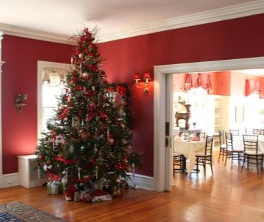
furnished, and professionally decorated to be elegant and stylish without losing the historical integrity of the house. While the manor boasts impeccable seasonal decor displayed through the year, the decorations are arguably the most beautiful at Christmas time. Classic decorative features
that accent, rather than take away from, the historical integrity of the
Rosemont at Christmastime
house, can be found throughout the main floor of the manor as well as on the Grand Staircase throughout the holidays. The breathtaking elegance of Christmas at Rosemont was featured most recently in Valley Homes and Style magazine’s Holiday 2011 edition.

Opened for Business
Once the restorations were complete for the manor house and all the government paperwork was
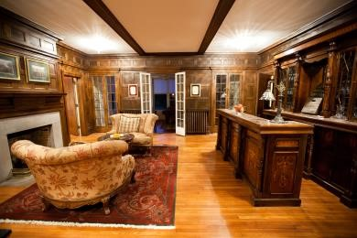
approved, Rosemont opened to bed and breakfast guests on September 3, 2010, a little over eleven months after the purchase by the Gendas. The former dining room where so many politicians and dignitaries had dined became the Nimitz Lounge where B&B guests check in, and wedding guests
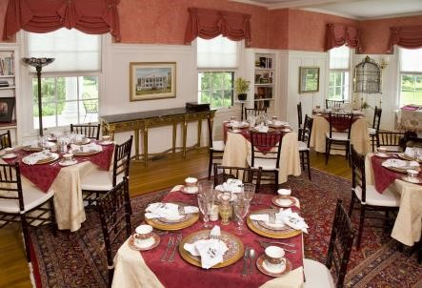
The Nimitz Lounge might order a cocktail. The former living room/library was transformed into a beautiful dining area, called the Rosemont Room, where Rosemont Manor House Tea events take place, and overnight guests enjoy their home-cooked breakfast. Senator Byrd’s study upstairs became a guest suite, aptly named the Byrd Study. The bedroom that the Senator and his wife shared in their early years at Rosemont was transformed into the Nixon Suite, and the two main floor bedrooms which the Byrds used in their later years were
combined to form the spacious Roosevelt Suite. _{The Rosemont Room}

Events
During the renovations, the Gendas were already making Rosemont available to its neighbors again. In October 2009 a benefit concert was held to honor Berryville Town Council Member Gail Smith, who died tragically in July 2009. The money raised at the event was used to create a scholarship in Gail’s name for
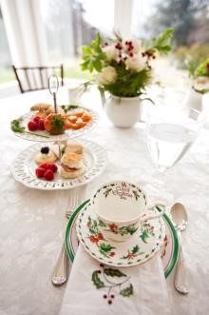
Clarke County High School seniors. Other special events that took place during the early days of the Genda era at Historic Rosemont were the Christmas Teas and the first annual Candlelight Tour and Open House to benefit local non-profit organizations.
Another big milestone was the first “official” Rosemont wedding, held on January 29, 2011. By the end of 2011, Rosemont had hosted close to 30 weddings, with even more expected for 2012. In addition, overnight bed and breakfast guest occupancy continues to
Table set for a rise, as does attendance at our Manor House Teas, held throughout the year on selected ^{Christmas Tea} Sundays.

The Grounds
Another important aspect to be protected and maintained was Rosemont’s great, historic trees. Throughout the 60 acre grounds, one can find rare and beautiful species of beech, maple, walnut, and cherry trees, just to name a few. Adjacent to the Grand Portico stands a prize specimen American Hornbeam which is the largest of its kind in the United States. It has been a top priority during the Gendas’ ownership to see that these trees are cared for and treated when necessary so that guests to Rosemont can continue to enjoy their statuesque beauty for years to come.

Visitors, Friends, and Family
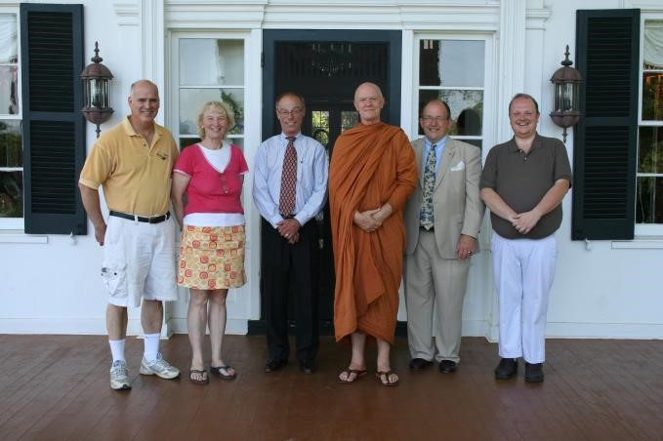
The Byrd family members have not been
strangers to Rosemont in recent months. Harry Byrd, Jr., now in his 90’s, came for a visit in 2010 and was most gracious in his appraisal of the restoration.
Then, in the summer of 2011, the adult children of
Dick and Helen Byrd stopped by, to the delight of the
Rosemont staff. Lucy, Bill, and Dick (called Ricky when
From left to right: Biff Genda (Owner and Proprietor), Lucy,
Michael Haymaker (Director of Weddings and Design), Dick,
Bill North, (General Manager), and Andrew Sheetz
he was young) shared stories of growing up at Rosemont – shooting pool in the basement, swimming in the pool, and being quietly ushered off to another part of the house when important guests were conversing in the dining room. Rosemont was also pleased to welcome the extended Byrd family and friends back in July of 2012 for the wedding of Langdon Greenhalgh, the great-grandson of Senator Byrd, Sr. Among the guests at the wedding were numerous descendants of the Senator, including Harry F. Byrd, V – a delightful 3-year-old who enjoyed romping around the manor and grounds that were so loved by his namesake.
In October of 2012, another exciting visit occurred at Rosemont that was reminiscent of the famous
political guests of the past. Retired 4-star general and Director of the CIA, David Petraeus and his family spent the weekend at Rosemont for their daughter Anne’s wedding. General Petraeus was gracious and personable, as was his family and security staff.
Another truly historical visit occurred in March 2013 when Rosemont welcomed John Byrd Norris, IV
and his wife Anne. Mr. Norris is the great, great-grandson of George Norris, the original owner and builder of Rosemont. “Jack” and Anne shared numerous historical documents and family genealogies that helped greatly in piecing together some of Rosemont’s earliest days.

It was also interesting to discover many of the Norris ancestors, including Jack himself, to have “Byrd” as a middle, or even first name. According to the Norris family’s research, there is no blood relation between the Norris and Byrd families, but those two clans shared a friendship
during the early 19th century. George Norris named his 10th son, John Byrd Norris I (Jack’s

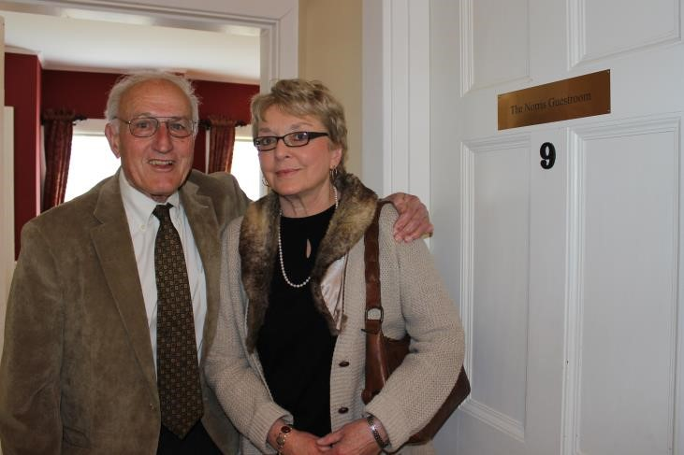
Descendants of George Norris, Jack and Anne, posing in front of the guestroom named in his honor
great-grandfather), after his friend Thomas Taylor Byrd, a direct ancestor of Senator Harry Byrd. Rosemont and the Byrd family appear to have been destined for one another all along.
In another exciting turn of events, Rosemont made its TV debut on November 1st, 2013 when the estate was featured on the hit CBS reality show “Undercover Boss”. The episode followed Paul Quentel, the President of bridal design company Alfred Angelo, as he went undercover in some of his own bridal stores.
The dramatic “reveal” scene when the employees learned of Quentel’s true identity was filmed on location at Rosemont. The television appearance brought wonderful publicity to Rosemont as a wedding venue and historic estate.
In its two centuries of life, Rosemont has seen the forming of a nation, the regeneration of families,
and the ebb and flow of life in the Shenandoah Valley. From Presidents to apple growers, from joyous births to sorrowful passings, Rosemont has been a haven and a home to all who have entered here. It is a welcoming place, a nostalgic place, and we hope that your history here becomes a time to fondly remember.

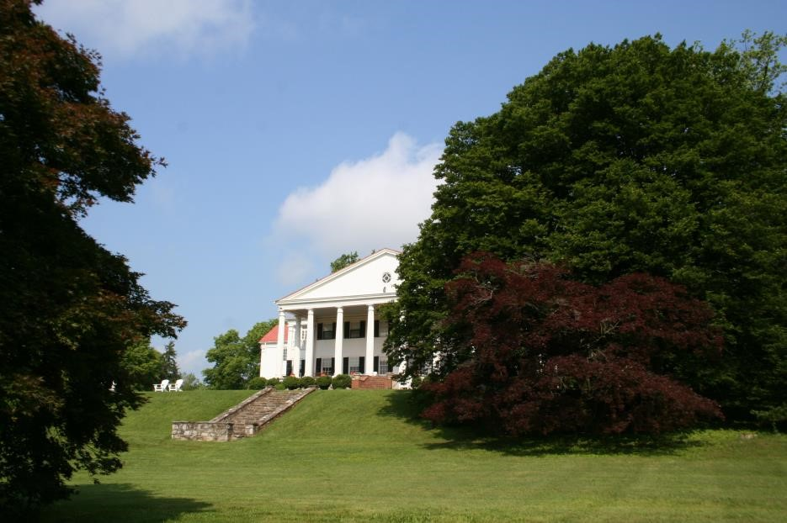
Historic Rosemont Manor

Bibliography
"Annual Fashion Show in Clarke County Sept 6th." Winchester Evening Star 27 Aug. 1968. Print.
"Bluegrass Benefit." Winchester Star 12 Oct. 2009. Print.
Burnham, Sophy. "Town and Country Visits the Daughters of the First Families of Virginia." Town and Country Dec. 1975. Print.
"Byrd Estate, Rosemont Is Garden Week Highlight." Richmond Times-Dispatch 21 Apr. 1968. Print.
Davis, Jack. "Simple Services Mark Burial of Harry Byrd, Sr." Winchester Evening Star 24 Oct. 1966. Print.
Fradin, Morris. "Berryville, VA: Gateway to History." Valleys of History 4.3 (1968). Print.
"Harry F. Byrd, Sr. Dies at Rosemont." Winchester Evening Star 20 Oct. 1966. Print.
Hatch, Alden. The Byrds of Virginia. New York: Holt, Rinehart and Winston, 1969. Print.
Hoffman, Marilyn. Hawthorne. Staunton, Virginia: Lot’s Wife Publishing, 2010. Print.
Johnsson, Johnny. Rosemont Farm, Berryville, VA - Tyson Era. Thesis. Finksburg, MD, 2002. Print.
Layne, Rebecca. "Room for Memories at Inn: Rosemont Open For Business." Winchester Star 2 Sept. 2010.
Print.
Layne, Rebecca. "Rosemont Entrance May Be Altered." Winchester Star 24 July 2010. Print.
Lewis, Kim. "A Haven for the Mighty." Mid-Atlantic Country Apr. 1986. Print.
Locke, Elizabeth L.F. "At Home: Classic Clarke County." Town and Country Oct. 1985. Print.
Kedzierski, Wendy C. “Rosemont Finds Holiday Nostalgia Through Time and Place.” Valley Homes and Style Holiday 2011. Print.
United States. Clarke County, Virginia. Clarke County Circuit Court. Court Registered Deeds and Documents.
1902 – 2009. Print.
Van Meter, Val. "Clarke Estate Is Sold: Genda Family Buys Rosemont." Winchester Star 1 Oct. 2009. Print.
Van Meter, Val. "Couple Keeps Tradition Bright: Rosemont Shines with Energy-Efficient Lights." Winchester Star 11 Dec. 2009. Print.
Van Meter, Val. "First Inn Show." Winchester Star 22 June 2010. Print.
Van Meter, Val. "Genda Family One Step Closer to Rosemont." Winchester Star 10 June 2009. Print.
Wilder, Layla. "Rosemont Could Become Town's First Country Inn." Clarke Courier 30 Apr. 2009. Print.

Fradin, Morris. “Berryville, VA: Gateway to History” Valley of History, Vol 4 No 3.
Hatch, Alden. The Byrds of Virginia, 1969.
Hatch, Alden. The Byrds of Virginia, 1969.
Hatch, Alden. The Byrds of Virginia, 1969.
Lewis, Kim. “A Haven for the Mighty”, Mid-Atlantic Country, April 1986.
Hatch, Alden, The Byrds of Virginia, 1969.
Hatch, Alden. The Byrds of Virginia, 1969.

